HUMAN FACE RECOGNITION:
EIGENFACES AND FISHERFACES

CSE555 |PATTERN RECOGNITION |SPRING 2014 UNIVERSITY AT BUFFALO

Contents
OBJECTIVE 3
PREPROCESSING 3
EXPERIMENTAL RESULTS 3
DISCUSSION 4

REFERENCE 13

OBJECTIVE

To implement two algorithms, namely the Eigenfaces and Fisherfaces algorithms, for face recognition with the Yale face database. To perform experiments to find out the average misclassification rates using these algorithms and discuss their implications.
The Eigenfaces algorithm is based on linearly projecting the image space to a low dimensional feature space [1]. This algorithm uses principal component analysis for dimensionality reduction, yields projection directions that maximize the total scatter across all the classes, i.e. across all images of all faces (preserve the variance).
Fisher’s Linear Discriminant is a classical technique in pattern recognition [1]. Depending upon the features used, it has been applied in different ways in face recognition. This algorithm yields projection directions that minimize the intra class variation but preserve the inter class variation [2].
The crucial point of difference between the two algorithms is that Eigenfaces is an unsupervised learning algorithm (as it is based on principal component analysis) but Fisherfaces is a supervised learning algorithm (as it is based on linear discriminant analysis).

PREPROCESSING
- The preprocessing stage comprises of the following steps:
- Creating data sets (training and testing) for the pattern recognition problem at hand.
- Normalizing the images (grayscale).
- Feature selection; based on standard deviation.
- Down sampling to reduce computational complexity.

We proceed to do feature selection. The first pre-processing step we apply for performing feature selection is to find the standard deviation of all the original features and remove only those features which deviate by less than 10%. At the end of this step we have significantly lesser number of features remaining.
- Upon finding the immense computational complexity of the algorithm, the decision to further down-sample the data. Down-sampling is performed by taking every 10th feature among the features selected in the above step.
- Note that you can observe the pre-processing performed in the first step via the MATLAB file – subsetCreate.m. Feature selection and down-sampling can be viewed via downSample.m.

EXPERIMENTS
In order to plot the misclassification rate, I will be conducting 10 runs of each experiment dataset for each K. K indicates the number of dimensions on which the mean faces have been mapped using the Eigenfaces algorithm. K = 10, 20, 30.
The following is the steps were carried out in this experiment:
- Created a random subset of 45 training examples, 120 testing examples.
- Performed preprocessing as described in the previous section.
- Leveraged principal component analysis (PCA) to calculate Eigenfaces.
- Implemented nearest neighbor classifier on Eigenfaces to classify training and testing data.
- Calculated misclassification rate for each dataset.
The above cycle of steps was conducted 10 times each (with a new random sampling of data) for K going from 10 to 30 in steps of 10. Thereby the data shown below or after running the MATLAB code – project_script.m on your terminal. Please read the readMe.txt file for instructions.

CLASSIFICATION TECHNIQUES PERFORMANCE COMPARISION

Experiment 1: Find optimal value of lambda
Lambda vs Accuracy & Time Taken
Lambda | Train Accuracy | Validation Accuracy | Test Accuracy | Time in Minutes
0 | 93.93% | 93.40% | 93.60% | 25.94523008
20 | 93.90% | 93.43% | 93.82% | 23.04805113
40 | 93.16% | 92.57% | 93.19% | 25.43447837
60 | 92.89% | 92.35% | 92.92% | 24.88755522
80 | 92.25% | 91.96% | 92.53% | 24.36446502
100 | 91.00% | 91.00% | 92.00% | 48.91666667
150 | 91.00% | 91.00% | 92.00% | 44.81666667
200 | 91.00% | 90.00% | 91.00% | 44.85
250 | 90.00% | 90.00% | 91.00% | 46.68333333
300 | 90.00% | 90.00% | 91.00% | 631.4333333
350 | 90.00% | 89.00% | 90.00% | 77.08333333
400 | 90.00% | 89.00% | 90.00% | 76.88333333
450 | 89.00% | 89.00% | 90.00% | 69.91666667
500 | 89.00% | 88.00% | 89.00% | 76.86666667
550 | 89.00% | 88.00% | 89.00% | 72.86666667
600 | 89.00% | 88.00% | 89.00% | 67.95
650 | 88.00% | 88.00% | 89.00% | 58.65
700 | 88.00% | 88.00% | 89.00% | 62.56666667
750 | 88.00% | 87.00% | 88.00% | 52.86666667
800 | 87.00% | 87.00% | 88.00% | 54.2

Table 1: Variation of prediction accuracy and time with lambda
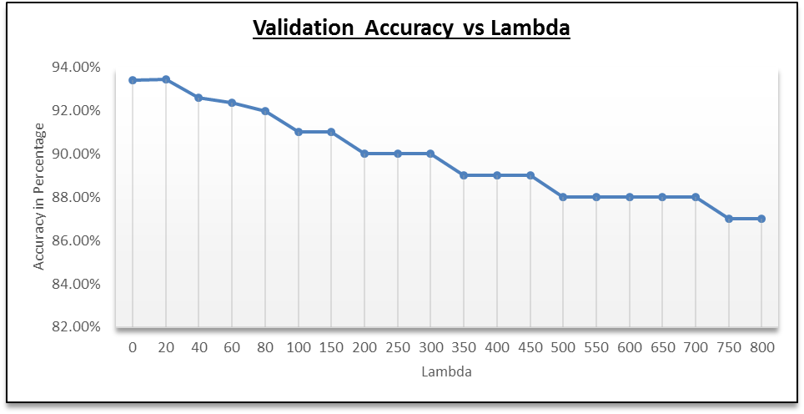
Figure 1: Plot of Validation accuracy against Lambda
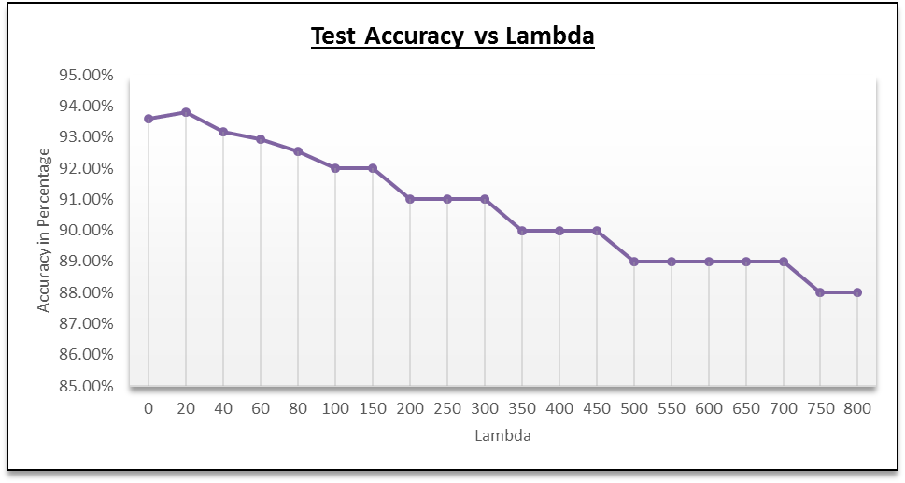
Figure 2: Plot of Test accuracy against Lambda

Experiment 2: Find the optimal number of hidden units
Hidden Nodes Analysis for best Lambda = 20
Hidden Nodes | % Train Accuracy | % Valid Accuracy | % Test Accuracy | Time seconds | Time in minutes
31 | 93.53% | 93.88% | 93.49% | 1358.24074 | 22.63734567
32 | 93.30% | 93.83% | 93.29% | 2073.759992 | 34.56266653
33 | 93.12% | 93.66% | 93.28% | 2156.97862 | 35.94964367
34 | 94.22% | 94.38% | 93.94% | 1291.142665 | 21.51904442
35 | 93.63% | 94.08% | 93.59% | 1580.839388 | 26.34732313
36 | 93.36% | 93.78% | 93.40% | 1886.606277 | 31.44343795
37 | 92.98% | 93.43% | 93.29% | 1492.073535 | 24.86789225
38 | 93.45% | 93.91% | 93.63% | 1415.519804 | 23.59199673
39 | 92.57% | 93.21% | 92.76% | 6316.5535 | 105.2758917
40 | 93.17% | 93.60% | 93.23% | 1790.180831 | 29.83634718
44 | 92.95% | 93.60% | 93.33% | 1786.824092 | 29.78040153
46 | 93.66% | 94.13% | 93.67% | 1741.98089 | 29.03301483
48 | 94.14% | 94.67% | 94.23% | 2526.269518 | 42.10449197
50 | 93.15% | 93.74% | 93.18% | 3585.191874 | 59.7531979
52 | 93.06% | 93.78% | 93.37% | 2485.267583 | 41.42112638
54 | 94.43% | 94.71% | 94.54% | 2495.555803 | 41.59259672
56 | 93.04% | 93.62% | 93.32% | 3171.10547 | 52.85175783
58 | 93.66% | 94.15% | 93.69% | 1751.545875 | 29.19243125
60 | 92.37% | 92.94% | 92.92% | 1775.818657 | 29.59697762
62 | 94.09% | 94.63% | 94.37% | 1793.620797 | 29.89367995

Table 2: Variation of Accuracy with Number of Hidden Units
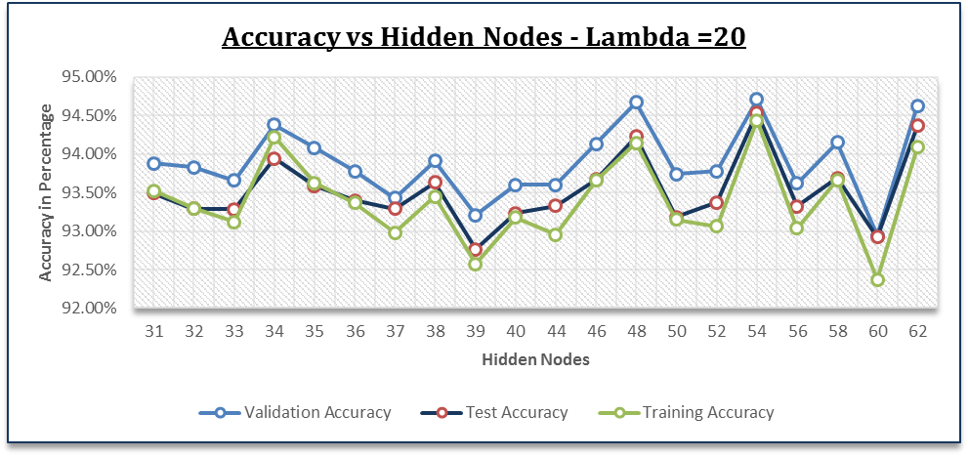Figure 3: Plot of Accuracy against Number of Hidden Units
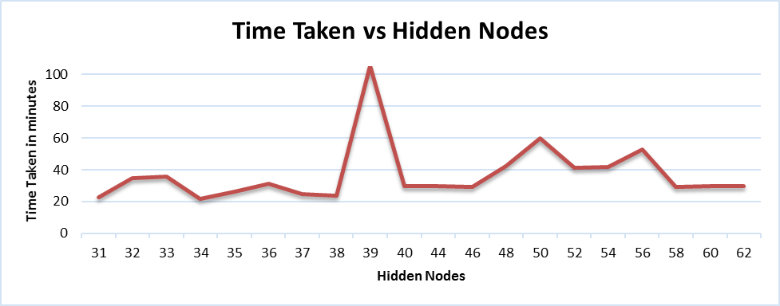
Figure 4: Plot of Learning Time against Number of Hidden Units

Experiment 3a: Find the optimal value of k for K-NN (NO TIE BREAKING)
KNN - ACCURACY & TIME TAKEN (NO TIE BREAKING)
K | Validation Accuracy | Time Taken | Scaled
1 | 97.61% | 770.516966 | 1
2 | 97.18% | 768.349507 | 0.99718701
3 | 97.68% | 768.724842 | 0.99767413
4 | 97.69% | 768.591207 | 0.99750069
5 | 97.63% | 768.831794 | 0.99781293
6 | 97.53% | 768.916971 | 0.99792348
7 | 97.50% | 768.80312 | 0.99777572
8 | 97.41% | 768.244467 | 0.99705068
9 | 97.36% | 768.444036 | 0.99730969
10 | 97.36% | 768.545268 | 0.99744107
Table 3: Variation of Validation Accuracy and Prediction Time with K
From the table above we can notice that the prediction accuracy are relatively low for K values 1 and 2 and then peak and post a certain value of K start decreasing. This is primarily due to over-fitting when the value of K is small and under-fitting when the value of K is very large. We therefore search for the point of inflection which shall be for the optimal value k; which is K=4 as per the data that we have gathered. We also find that the time taken is significantly lesser than the time by ANN.
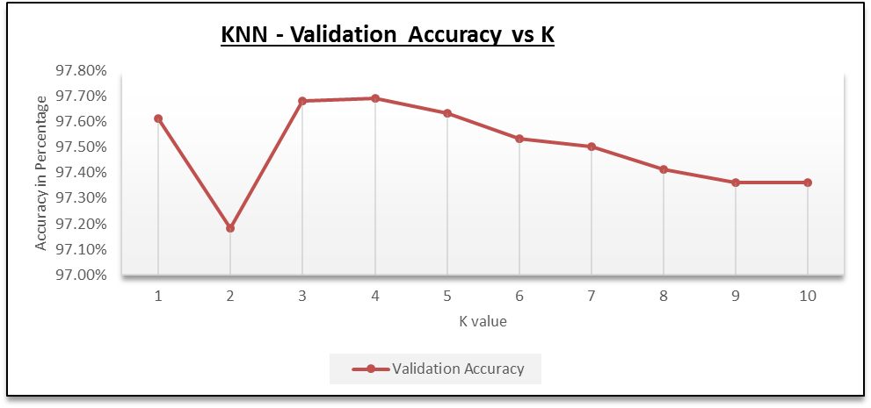
Figure 5: Plot of Validation Accuracy against K
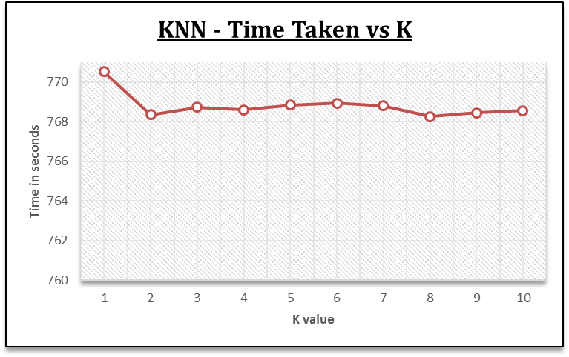
Figure 6: Plot of Actual Time Taken against K

Experiment 3b: Find the optimal value of k for K-NN (WITH TIE-BREAKING)
KNN - ACCURACY & TIME TAKEN
K | Validation Accuracy | Test Accuracy | Time Taken | Scaled
1 | 97.46% | 97.09% | 871.37741 | 0.948459
2 | 97.46% | 97.09% | 878.151074 | 0.955832
3 | 97.56% | 97.30% | 918.729368 | 1
4 | 97.67% | 97.37% | 917.785007 | 0.998972
5 | 97.68% | 97.27% | 917.626729 | 0.9988
6 | 97.71% | 97.20% | 917.597596 | 0.998768
7 | 97.50% | 97.15% | 917.832789 | 0.999024
8 | 97.65% | 97.24% | 917.600584 | 0.998771
9 | 97.51% | 97.02% | 917.789408 | 0.998977
10 | 97.49% | 97.13% | 917.775534 | 0.998962

Table 4: Variation of Validation and Test Accuracy, and Prediction Time against K
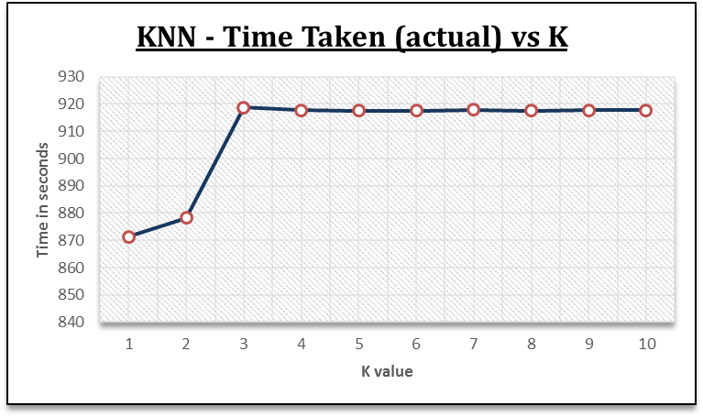
Figure 7: Plot of Actual Prediction Time vs K

Figure 8: Plot of Validation and Test Accuracies vs K
In the Find the optimal number of hidden units

5

9

10

11

from zero to 800. What this means is that we started with gitance to error afte Another point is that if the time required for training is ignored and only the testing phase times for K-NN and ANN are compared, then ANN would perform much faster than K-NN. Therefore, using ANN would be beneficial in scenarios where a learnt model needs to be constantly applied to thousands of test instances, for example, in a bot. Whereas, K-NN would work faster where there are fewer test examples.

The comparison of the varying values of the hyper-parameter, lambda, referring figure z, the validation accuracy peaks at 20. This leads us to infer that we need to smooth the error function by a value of 20 using the weight vectors learned after each epoch of learning. Also, since lambda = 0 provides a lower accuracy for validation, along with the fact that regularization becomes an important aspect to mitigate over-fitting in our high dimensional classification task.

For the K-NN classifier, we are using cosine similarity measure to find the distance between examples. Refer figure y, the accuracy of our validation set is best for value of k = 6. That is, if we see the six closest neighbors using the similarity measure used provides us the best prediction accuracy on our validation dataset. We attribute this to the value which corresponds to the most optimal value of k with the number of dimensions we have. An important point to note, while using cosine distance measure, is that we find that cosine similarity is substantially good measure for high dimensional spaces [1].

CLASSIFICATION TECHNIQUES
Metric |  | Eigenfaces | Fisherfaces
Training Time &  Accuracy | Lot of Training Examples | Takes a long time to learn the weights for each feature at each layer of the neural network | Does take time but lesser than ANN does; to learn the value of k that shall help KNN to rightly classify examples
Training Time &  Accuracy | Not many Training  Examples | Takes longer than KNN to learn as it needs to learn the weights for each feature; but does take lesser time than when it has to learn from a dataset that has lot more examples. Cannot guarantee good prediction accuracy due to lack of examples. | Does not take as much time as ANN to get the value of K; takes lesser time than when it has to learn from a dataset that has lot more examples. Cannot guarantee good prediction accuracy due to lack of examples.
Training Time &  Accuracy | Small number  of features | Learning shall happen faster but suffers from lack of features | Suffers from lack of features
Training Time &  Accuracy | Large number  of features | Does not suffer from curse of dimensionality. If there are many features and amongst them are features that do not necessarily contribute in helping rightly classify an example then those features are turned off, by adjusting the weights. | Suffers from curse of dimensionality; does not have a means of identifying the features that do not have any significance and therefore ends up treating all features as equals which need not necessarily be the right thing to do
Prediction Time |  | Irrespective of the dataset size the prediction time shall be lesser than KNN | Time taken to predict shall be longer than ANN irrespective of dataset size
Complexity |  | Fairly Complex: ANN learns a model whose parameters are the Weights, at each layer of the neural network, for each feature and the hyper-parameters namely; lambda and hidden nodes. The complexity makes ANN more trustworthy in terms of the predictions that it makes on testing data | Low Complexity: KNN does not learn much from the examples in the training set, other than finding the optimal value of K for which the classification accuracy is highest. In that way one can look at it as one parameter model with no other parameters to act as checks and balances. This could result in low prediction accuracy w.r.t testing data
Sophistication of Classification
method
Ideal For |  | Good for dealing with random noise, but not good for rotation-scaling-translation distortion. It could minimize the distance between projection space and data space, and really reduce the redundancy.  The performance is weaker than when using stand alone correlation [2]. | Can be used for any kind of classification problem. Not sophisticated in dealing with RST distortion. Noisy data creates problems [2].

REFERENCE

[

1] P. Belhumeur, J. Hespanha and D. Kriegman, “Eigenfaces vs. ﬁsherfaces: recognition using class speciﬁc linear projection,” IEEE PAMI, 1997 (A local copy: http://www.cse.buffalo.edu/~qianliu/PR/Project/1/ref1.pdf ).
[2] Harry Chao’s slides on Eigenfaces and Fisherfaces.
(Online available: http://disp.ee.ntu.edu.tw/~pujols/Eigenfaces\%20and\%20Fisherfaces.pdf
[3] Pattern Classification, 2nd Edition: Duda, Hart, Stork.

